Cumulative Resource Consumption (Prefix Sum)

Aim
To compute the prefix sum (cumulative sum) of an array, where each element represents the sum of all elements from the beginning of the array up to the current index.

Pseudocode
START

Read N
Read array arr[0...N-1]

prefix[0] = arr[0]

FOR i = 1 TO N-1 DO
prefix[i] = prefix[i-1] + arr[i]
END FOR

FOR i = 0 TO N-1 DO
Print prefix[i]
END FOR

STOP

Program:
#include <stdio.h>

int main() {
int N;
scanf("%d", &N);

int arr[N], prefix[N];

for (int i = 0; i < N; i++) {
scanf("%d", &arr[i]);
}

prefix[0] = arr[0];

for (int i = 1; i < N; i++) {
prefix[i] = prefix[i - 1] + arr[i];
}

for (int i = 0; i < N; i++) {
printf("%d ", prefix[i]);
}

return 0;
}

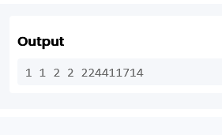

Result:
The program successfully computes and displays the prefix sum (cumulative sum) array.

